Beta Squad: VR Expedition

User’s Guide

Michael Chiro, Stefan Farian, Westin Fishel, Patrick Seeman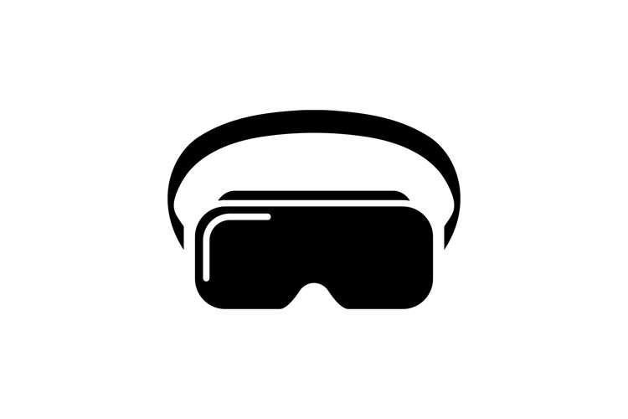

**Table of Contents**

1. Introduction………………………………………………. 2
   1. Description………………………………… . 2
2. Installation……………………………………………….. 2
   1. System Requirements……………………. 2
   2. Controller Walkthrough…………………… 2
3. UI Overview…………....………………………………… 4
   1. Select Video Folder..………………………. 4
   2. Tour Setup……….…………………………. 6
   3. Start Tour………..………………………….. 6
   4. Quit………………………………………….. 7

**1. Introduction**

1.1 Description:

The goal of the 360 Video Viewer is to take a Virtual Reality (VR) tour with videos the user imports. Users can place videos in the location they choose in the form of ‘interactables’, resulting in a custom tour that is easy to navigate.The finished project has two modes for the user: an administrator mode and tourist mode. Administrator mode allows project managers to build the custom tour with user input, and tourist mode implements user input to follow the tour that was built for them. Alternatively, keyboard and mouse input also works with the functionality of this application.

1. The main menu has four options:
   1. Start Tour - This is where the videos are displayed and one can look around the tour.
   2. Select Video Folder - This is where the user navigates the file explorer and selects the folder of .mp4 (video) files to use for the tour.
   3. Tour Setup - Allows the user to order the videos in the way they choose
   4. Quit - Exits the program back to the main menu.

**2. Installation**

2.1 System Requirements

* + 1. VR Hardware: **​​**Valve Index, HTC Vive, Oculus Rift, or Windows Mixed Reality with the compatible controller
    2. GPU: NVIDIA GTX 970 / AMD R9 290 equivalent or greater
    3. CPU: Intel i5-4590 equivalent or greater
    4. RAM: 8GB+
    5. Video Output Compatible HDMI 1.3 video output
    6. USB Ports 3x USB 3.0 ports plus 1x USB 2.0 port
    7. OS Windows 7 SP1 64 bit or newer
    8. Executable of VR Expedition
    9. Folder of .mp4 videos

2.2 Controller Walkthrough

1. Keyboard Inputs (2D functionality):
   1. Arrow keys: rotate the camera to view the video as if you are turning your head with a headset.
   2. A, W, S, D buttons: same functionality as the arrow keys. These buttons serve as an alternate if any arrow keys are broken, or user preference.
   3. R button: Resets camera’s position to the default angle.
   4. Escape or M button: takes the user back to the main menu of the application.
   5. Q button: quits/closes out the application entirely.
   6. I button: inverts the vertical camera rotation keyboard functionality.
   7. H and L button: makes camera rotation sensitivity higher and lower.
2. HTC Vive Controllers (3D functionality):
   1. The image below shows the HTC Vive wands as well as the different components of them.

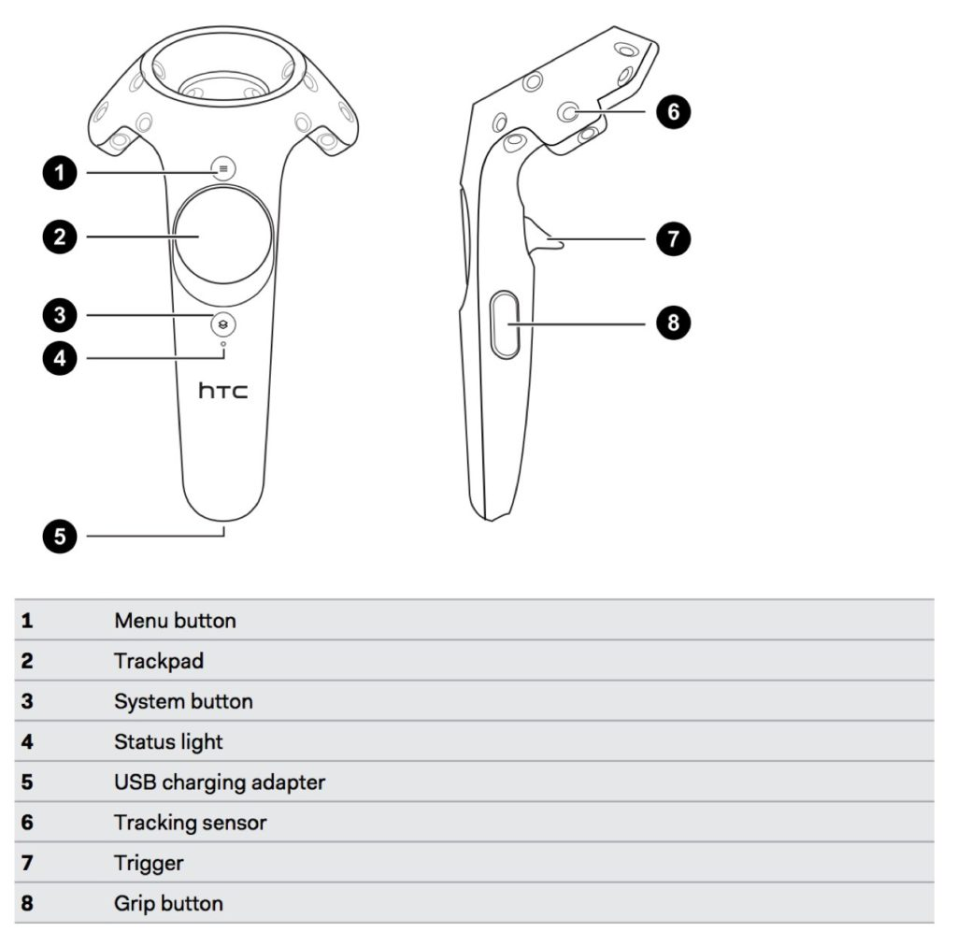

**3. UI Overview**

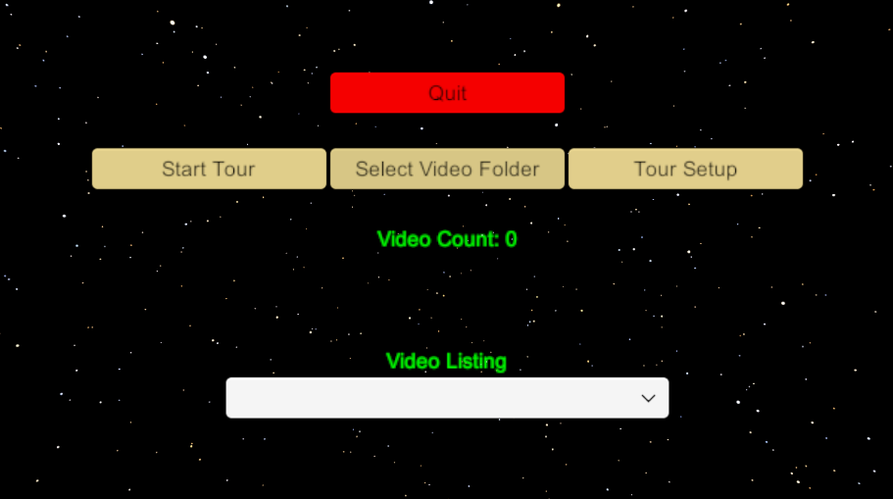

The screenshot above shows the main menu screen. This consists of four different buttons: Start Tour, Select Video Folder, Tour Setup, and Quit. As well as those buttons, it also contains the video count and the videos listed.

3.1 Select Video Folder

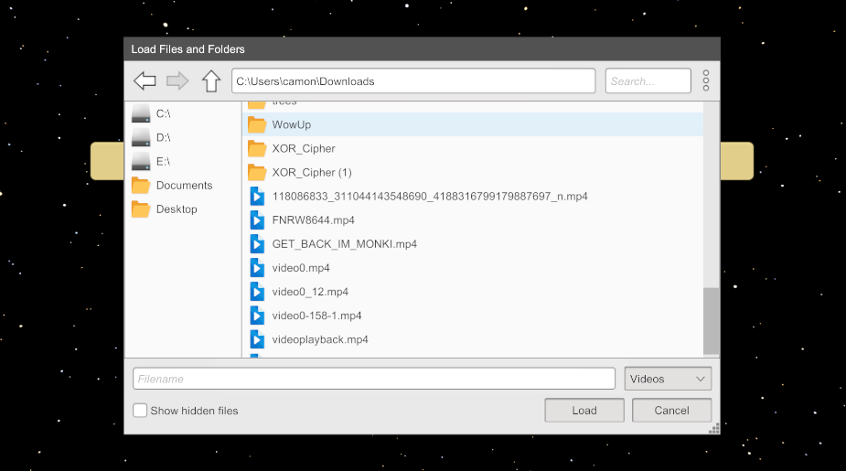

When the button “Click to Load Videos” is pressed, the user is able to navigate through their file directory, and select a folder that strictly contains .mp4 files.

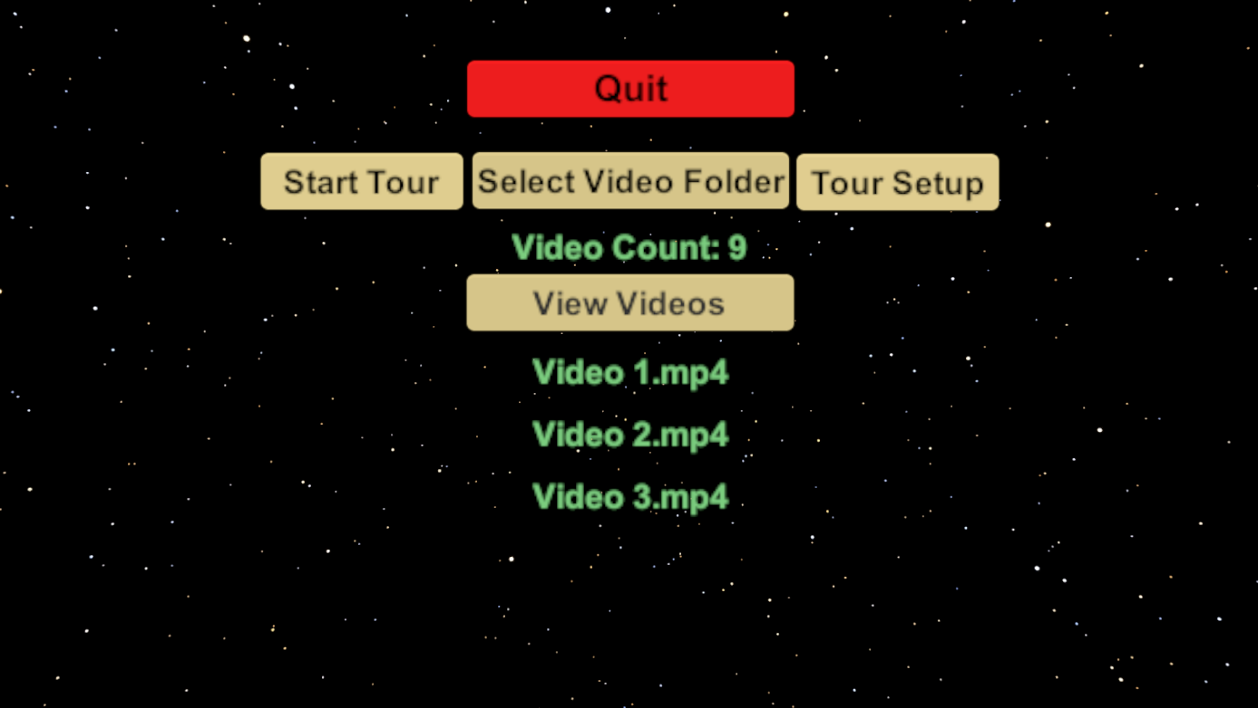

Following this, when a folder is selected with .mp4 files, the “Video Count” is displayed, so when a folder of 9 videos is selected, the “Video Count” changes to 9.

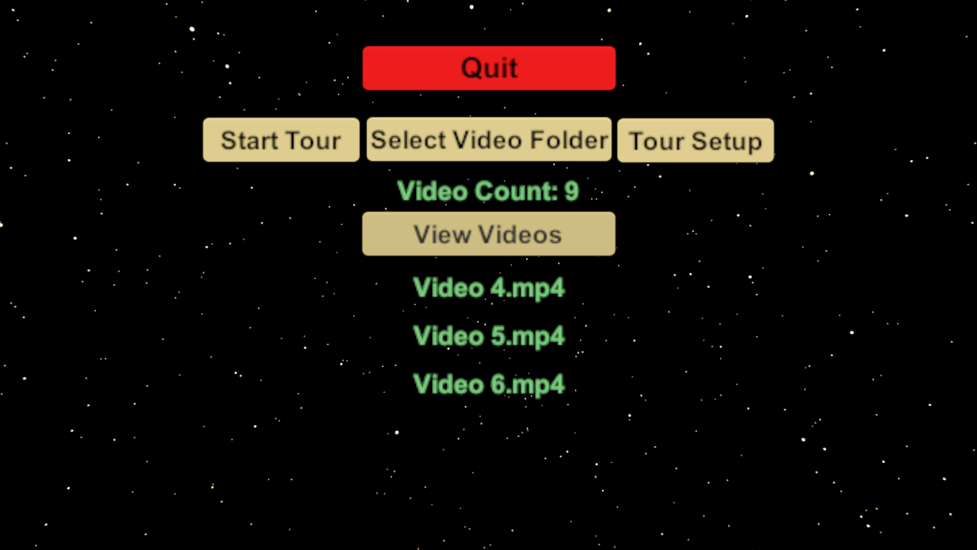

When the “View Videos” button or the “n” key is clicked, the videos in the folder cycle through as the image above shows

3.2 Tour Setup

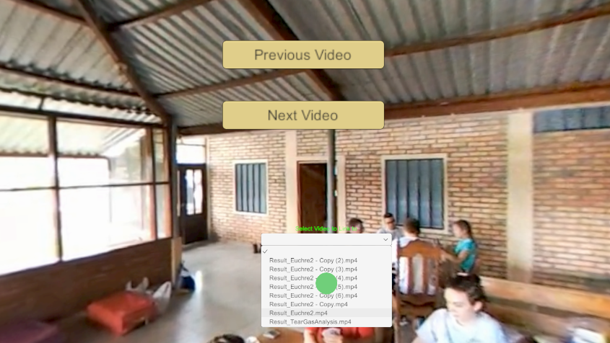

Allows the user to order the videos that they imported from their folder in the by creating an interactable, selecting the drop down menu, and pressing the trigger on their video of choice

3.3 Start Tour

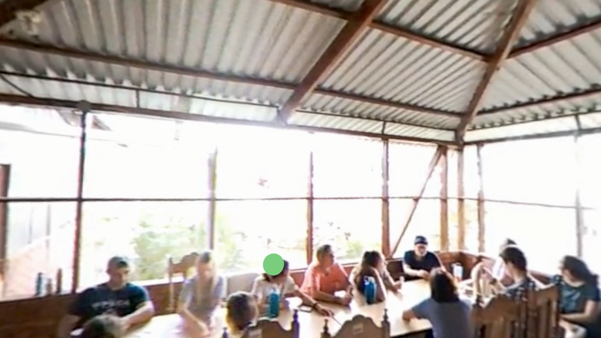

The image above shows an example of a tour created with the VR Expedition. This is the first scene of the tour. The cucumber green circle on the screen is an interactable, so when clicked, it will move onto the next scene of the tour.

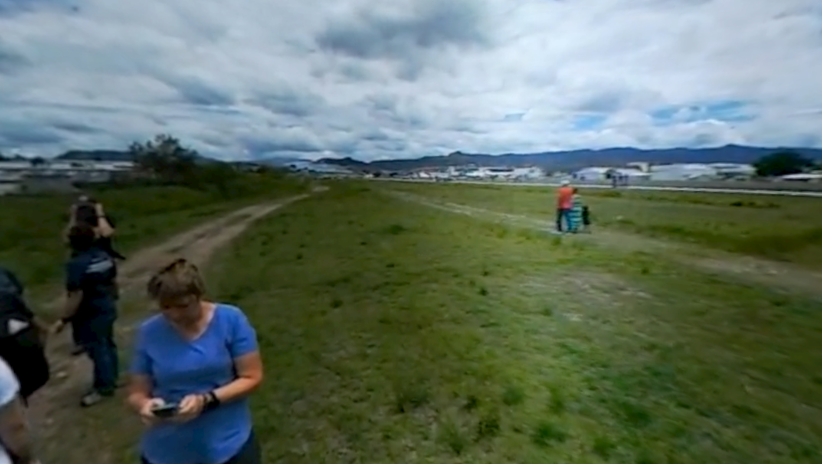

When the cucumber green interactable is clicked, the scene changes to the next video that the user selected

3.4 Quit

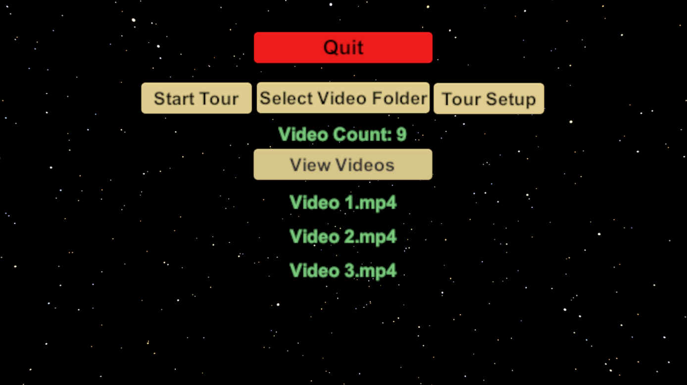

The quit button closes out the application, and takes you back to your desktop screen. Any work done on setting up a tour is saved, and can be pulled back up once you reselect the same video folder